Modelling of Diagnostics for Space Charge Studies on the ISIS Synchrotron
B. G. Pine, C. M. Warsop, S. J. Payne, Rutherford Appleton Laboratory, Oxfordshire, UK

Abstract
The ISIS Facility at the Rutherford Appleton Laboratory in the UK produces intense neutron and muon beams for condensed matter research. It is based on a 50 Hz proton synchrotron which, once the commissioning of a new dual harmonic RF system is complete, will accelerate about 3.5E13 protons per pulse from 70 to 800 MeV, corresponding to mean beam powers of 0.2 MW. Transverse space charge is a key issue for both present and proposed upgrades to the machine, and is the focus of current R&D studies. Experiments on the ISIS ring are central to this work, therefore understanding and quantifying limitations in present and proposed diagnostics is essential. This paper presents work studying and modelling the ISIS residual gas profile monitors, including the effects of non-uniformity in drift fields and proton beam space charge. Progress on related work looking at beam position monitoring is also summarised.

introduction
The ISIS synchrotron has a circumference of 163 m, with mean half apertures of 60 by 80 mm. Beam is accumulated over about 130 turns using charge-exchange injection, and then formed into two bunches during acceleration. Space charge levels are especially high during injection and bunching, though still have a significant effect when the beam is extracted. ISIS residual gas profile monitors have operated successfully for many years, but higher intensity operation and related beam studies are motivating a more detailed analysis. The operation of the profile monitors is based on guiding and detecting the ions produced when the residual gas is ionised by the passing proton beam, in a process assumed to be proportional to the local beam intensity. Reliable profiles depend on linear ion trajectories between the generation point and the detection point, i.e. in a vertical monitor the horizontal position of the ion should not change from creation to detection. Two effects which prevent this are studied (1) distortion in the drift field and (2) beam space charge.
Control of ring closed orbit errors is important for high intensity operations, therefore detailed models of position monitors have been developed to check their calibration.

Profile Monitor

Computer Model
A detailed geometrical model of the profile monitor was developed in the EM field solver, CST Studio Suite [1]. This was used to calculate the electrostatic field generated by the drift electrodes and the beam space charge. The resulting field was then extracted and used to calculate ion trajectories, and the corresponding beam profile. The ISIS profile monitors consist of a twinned set of electrodes and detector housings, with the electrodes paired to cancel any influence on the beam itself, see Figure 1. The longitudinal and transverse potential distributions are shown in Figure 2. Whilst the situation was acceptable in the longitudinal plane (a), it was clear that the field in the transverse plane (b) could have a distorting effect on the final beam profile.
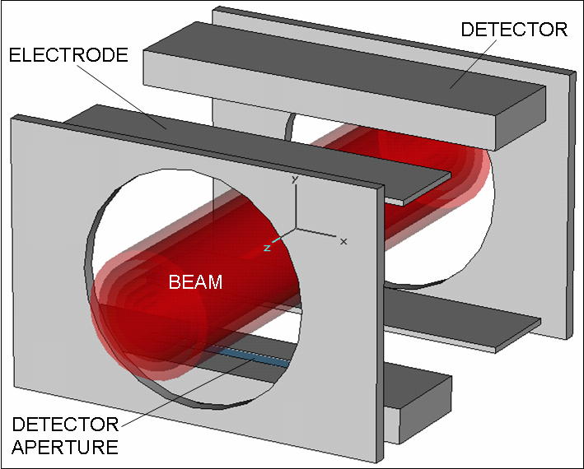
Figure 1: Profile monitor geometry.
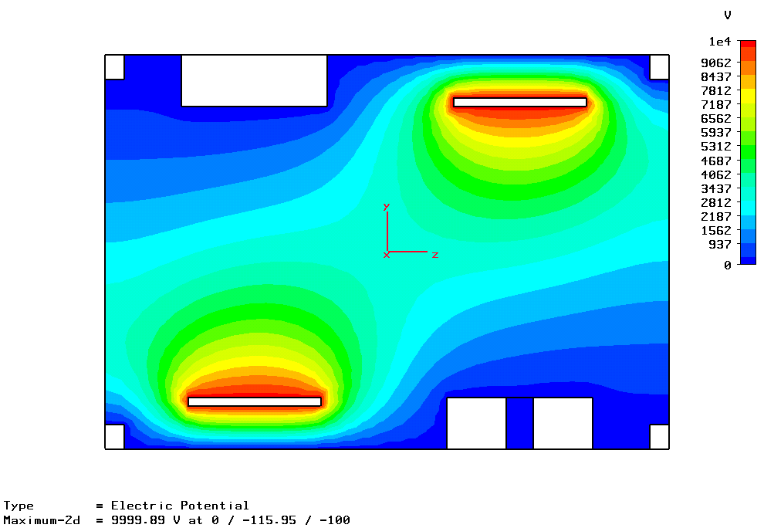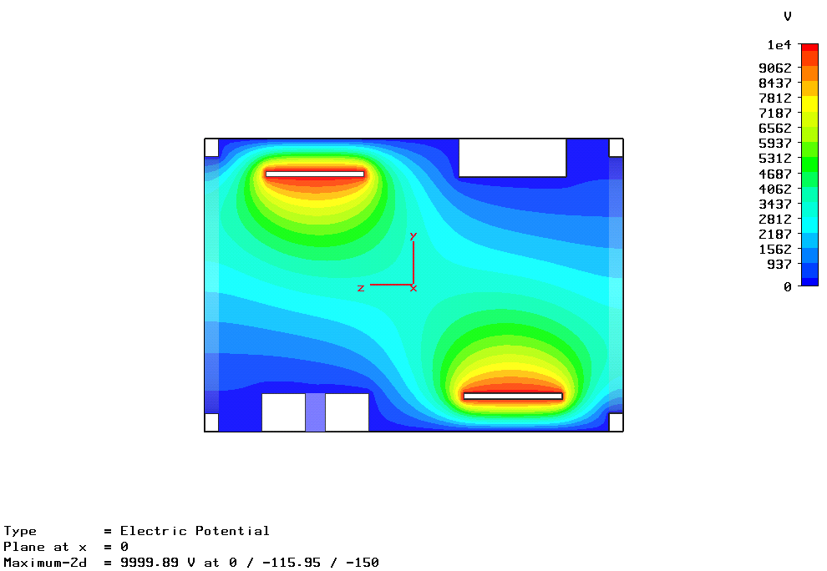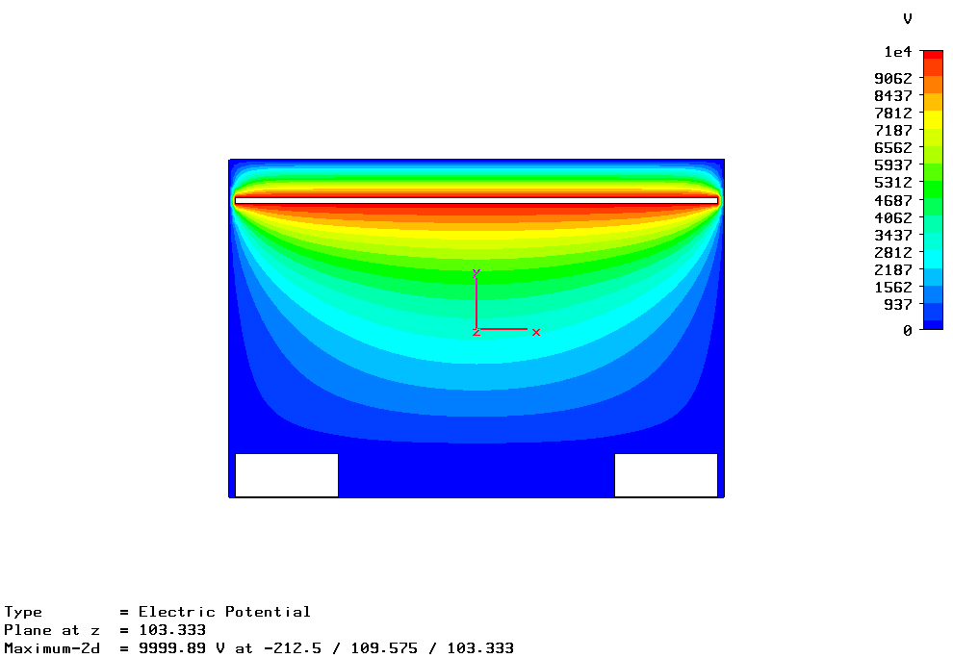
Figure 2: (a) Longitudinal and (b) Transverse electrostatic potential distributions.
Detailed and accurate calculations of the ion trajectories were essential for this work, and limitations in the CST software motivated development of some dedicated, optimised particle tracking code. Test particles, or more complex ion distributions, were tracked through 2D field maps extracted from the CST model. Particles were spawned from a uniform 2D grid at a rate proportional to the simulated beam density at each grid point. These particles were then tracked to the detector position, where they generated a histogram, i.e. profile. Finite resolution in the starting grid could lead to systematic distortions in generated profiles – to avoid this a random offset was applied to each particle.

Effects of Drift Field
Figure 3(a) shows the results of tracking ions from a 2D parabolic distribution through the transverse electrode field of the ISIS monitors, with zero space charge. Figure 3(b) shows the resulting beam profile (‘Detected’ in the figure) compared with the situation of a perfect, linear field (‘Ideal’).
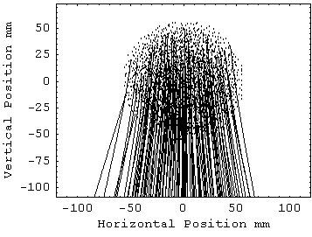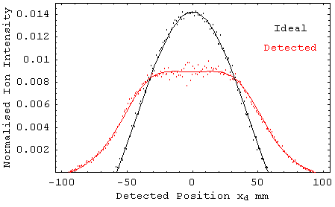
Figure 3: (a) Particles tracked through electrode field, and (b) Detected vs. ideal profile simulations.
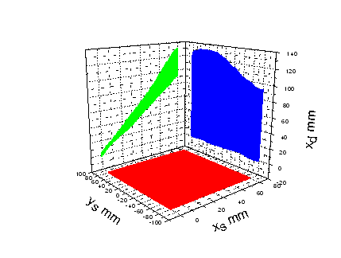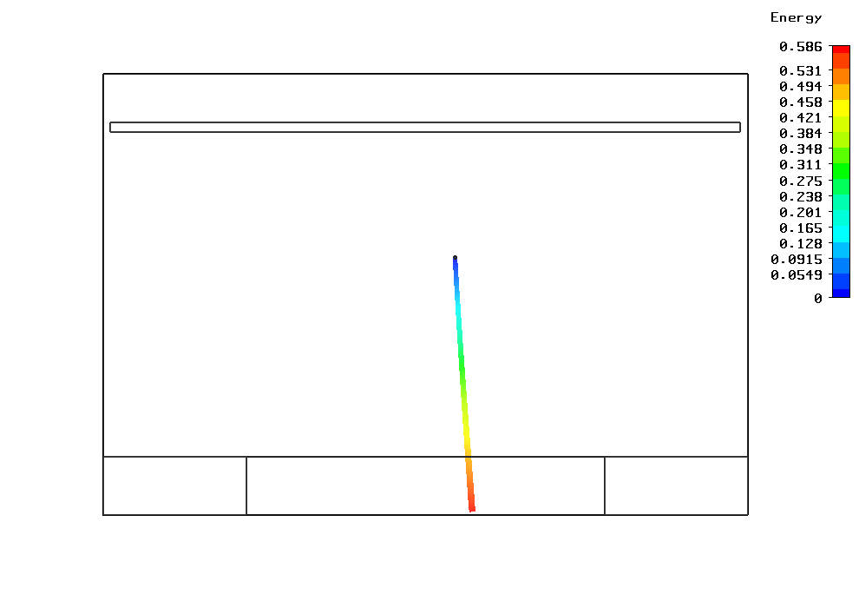
(x_{s}, y_{s})
x_{d}
ELECTRODE
DETECTOR
PARTICLE TRAJECTORY
Figure 4: (a) CST trajectory results showing notation, (b) Simulated detector response, compared with ideal situation.
To analyse the effect of non-linearity in the drift field, particles were tracked from a rectangular grid of starting points: x_{s} = 0 → 80 mm, y_{s} = -80 → 80 mm, to their final destination x_{d} at the detector. This is illustrated in Figure 4(a). The relationship x_{d} = f(x_{s}, y_{s}), defines a surface, the projections of which are shown in Figure 4(b), with the ideal profile response drawn as lines on top.
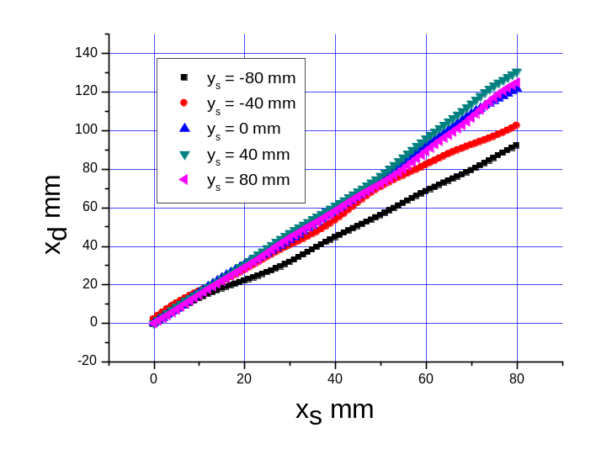
Figure 5: Relationship between starting and detected horizontal position for different vertical heights.
Figure 5 displays x_{d} against x_{s}, for various y_{s}. These map out the same shape as the x_{d} x_{s} projection in Figure 4(b), but also show how the projection is made up from different elevations within the original ion distribution. There are some surprising features: for instance, the line of ions at y_{s} = 40 mm is distorted more than that at y_{s} = 80 mm, despite the latter having a longer drift distance. The average gradient of all y_{s} lines gives a first estimate of the ratio of detected width to ideal, and is approximately 1.45, although this may be modified by a number of factors, e.g. horizontal or vertical beam offset.

Effects of Space Charge
Ions are also affected by the electric field of the beam itself. This field is nonlinear, and will act outwards from the centre of charge. The deflected ion trajectories will therefore also depend on details of beam distribution and intensity. Charge distributions were created by applying a charge density function to concentric cylindrical rings in CST Studio Suite, then field distributions were extracted, particles tracked and profiles constructed as before. This approach could easily be extended to more realistic beam shapes. For present purposes, it was sufficient to use uniform, elliptical and parabolic beams. An example of this model is shown in Figure 6(a), with a round, parabolic density beam, constructed from 10 concentric rings. Figure 6(b) is a 2D potential representation from CST Studio Suite where space charge is almost totally dominant over the electrode field.
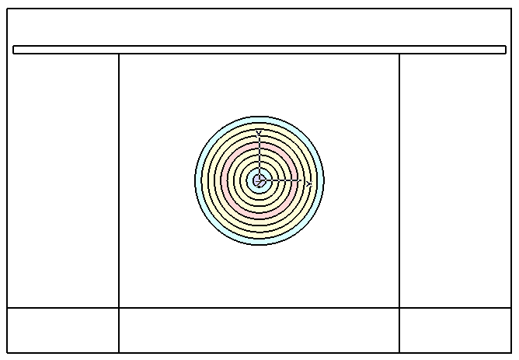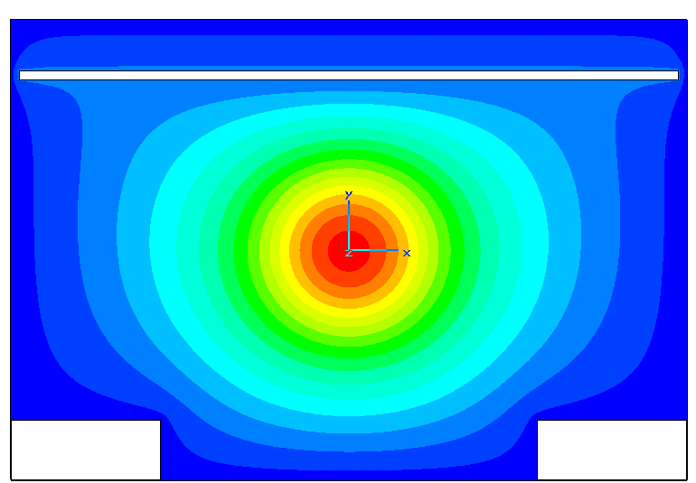
Figure 6: (a) Concentric ring space charge model, and (b) Space charge dominated potential.
A critical factor in determining errors due to space charge fields is the relative strength of the drift field. Figure 7 shows the variation in profile given by the model for parabolic density space charge and particle source, with drift field swept from 10 kV to 100 kV.
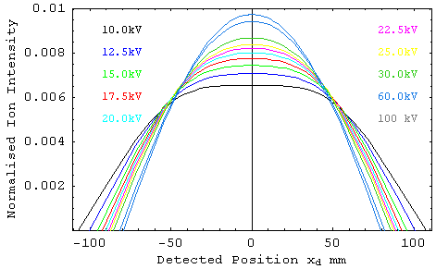
Figure 7: Profiles vs. Electrode Voltage.
In some previous studies [2] the effect of drift field strength on 90% beam width was measured experimentally, and shown to follow a simple theoretical model [3]:
Detected width = Real width + 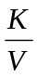 (1),
where K is a constant related to beam energy and intensity. The experimental results, simple theory and simulation results are shown in Figure 8. The results in [2] initiated an upgrade in drift field voltage from a maximum of 30 kV to 60 kV, which will certainly reduce errors. These simulations have demonstrated that a significant proportion of the Real width from (1) is due to the effects of non-linearity in the electrode drift field.
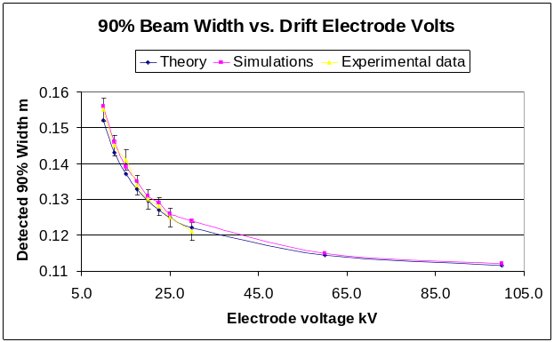
Figure 8: Effects of drift field strength with space charge.

Position monitor
ISIS split cylinder capacitative position monitors have also been modelled with CST Studio Suite, the geometry and potential distribution of these monitors is shown in Figures 9 and 10. Standard theory [4] states that the beam
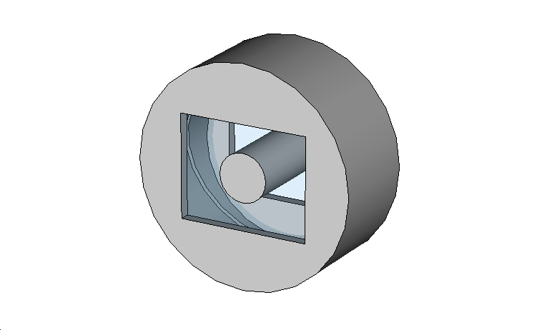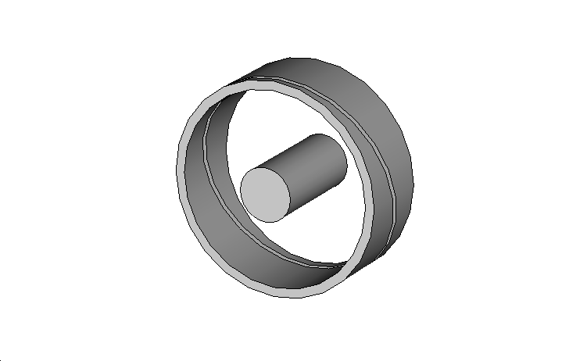
GROUNDED HOUSING
ELECTRODES
BEAM
Figure 9: ISIS position monitor.
centroid position x is related to the two electrode voltages V₁, V₂ by:
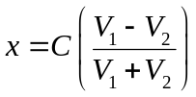 (2).
Approximate theory gives the calibration constant C as 1/R, where R is the geometrical radius of the electrodes. A set of results obtained from the CST model determined the electrode potential as the beam was scanned over both transverse dimensions. Figure 11(a) shows the electrode potentials and Figure 11 (b) shows the difference over sum for those potentials. It can be seen that the linearity predicted by (2) was confirmed. However, it was also found that the value of C often deviated significantly from 1/R, being related to the ratio of electrode radius with length and also to the longitudinal boundary conditions.
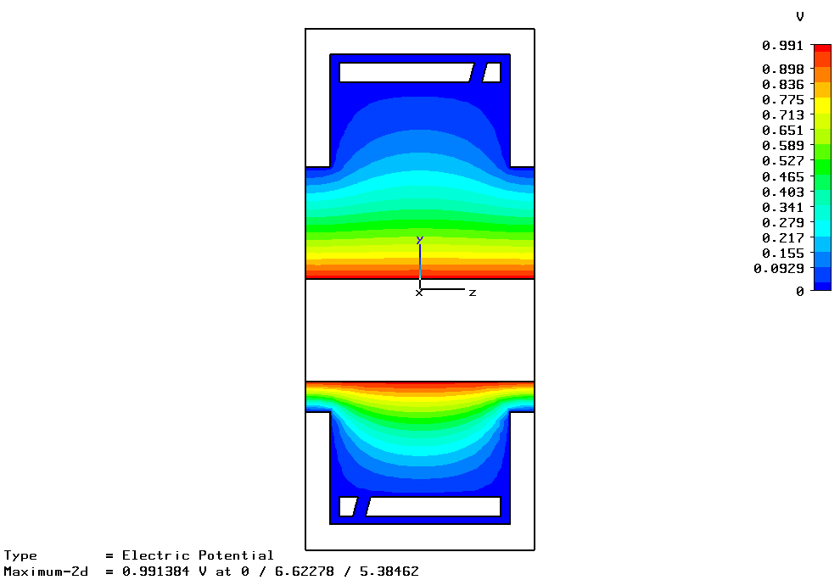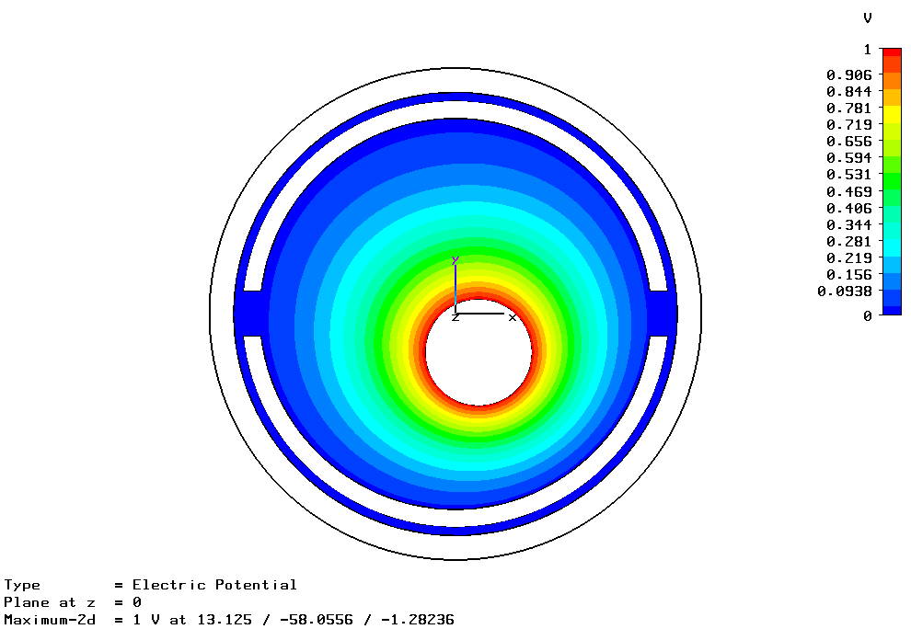
Figure 10: ISIS position monitor potentials with offset beam.
On ISIS monitors undergo a series of checks that ensure correct operation, with final calibration based on beam measurements, therefore serious alignment problems are avoided. However, this work will aid improved calibration of some non-standard geometry monitors used in the extraction/collimation straight where alignment is particularly important.
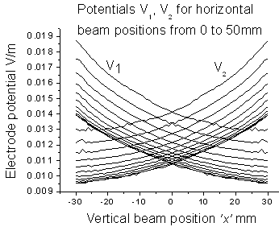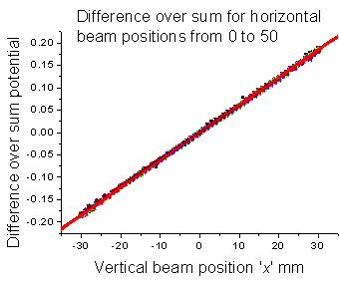
Figure 11: (a) Electrode potentials and (b) Difference over sum.

Conclusion
A detailed model of the ISIS residual gas profile monitors is providing essential information on the limitations and errors of these devices. Results have agreed well with experiments so far. Further checks are planned, comparing results with ‘wire harp’ monitors in the extraction beam line. Ultimately, studies will provide correction algorithms for the present devices, or recommend a modification of hardware.
Position monitor studies are providing a more detailed understanding of monitor calibration, which is expected to help ensure optimal beam alignment.

References
[1] www.cst.com.
[2] S. J. Payne et al, “Investigation into the relationship between the Drift Field Voltage and the measured Beam Width in the ISIS Ring Beam Profile Monitor System”, Rutherford Appleton Laboratory, ISIS Machine Physics Report IADM/MPS/2.1/03, (2003).
[3] R. E. Thern, “Space charge distortion in the Brookhaven ionization profile monitor”, PAC Wash., D.C., p646, (1987).
[4] R. E. Shafer, “Beam Position Monitoring”, AIP Conference Proceedings Vol 212, (1989).

