The role of collisions on mode competition between the two-stream and Weibel instabilities

K. A. Humphrey^{1*}, R. M. G. M. Trines², D.C. Speirs¹, and R. Bingham^{1,2}

¹SUPA, Department of Physics, University of Strathclyde, Glasgow, G4 0NG, UK
²STFC Rutherford Appleton Laboratory, Chilton, Didcot, Oxfordshire, OX11 0QX, UK

PACS numbers:

Abstract
We present results from numerical simulations conducted to investigate a potential method for realizing the required fusion fuel heating in the Fast Ignition scheme to achieving inertial confinement fusion. A comparison will be made between collisionless and collisional particle-in-cell simulations of the relaxation of a non-thermal electron beam through the two-stream instability. The results presented demonstrate energy transfer to the plasma ion population from the laser driven electron beam via the non-linear wave-wave interaction associated with the two-stream instability. Evidence will also be provided for the effects of preferential damping of competing instabilities such as the Weibel mode found to be detrimental to the ion heating process.
Inertial confinement fusion (ICF) research exploits the high energy density and photon flux achievable by modern lasers to compress and heat solid pellets of material resulting in very high density plasma. The emergence of the concept of Fast Ignition significantly reduces the requirement for laser energy and mitigates a range of plasma instabilities that may affect conventional inertial fusion plasmas, by separating the processes of thermonuclear fuel compression and burn.
It is anticipated that beam-plasma instabilities driven by the relativistic electron beam generated in Fast Ignition will play a crucial role in the coupling of the laser energy to the fuel target [1, 2]. These include the two-stream, Weibel and filamentation instabilities. Of particular interest is the two-stream mode which is a major collective effect found in counter-streaming plasmas drifting relative to each other, with a constant velocity much greater than the thermal spread of the beams. This instability may provide a method for achieving the required fusion fuel heating via the relaxation of the non-thermal electron beam through this mode. The two-stream process generates Langmuir waves that parametrically decay into lower amplitude Langmuir waves and ion acoustic waves that are strongly damped by ion collisions in the dense plasma, resulting in energy transfer to the background plasma ion population [3, 4]. The competing instabilities such as the Weibel and filamentation are detrimental to the ion heating process [5, 6] as they could inhibit the ability of the two stream’s instability to excite Langmuir turbulence and provide the energy required for ion heating. It is therefore essential to minimize the effects of these competing modes.
In the current context numerical simulations have been conducted using the OSIRIS particle-in-cell code to investigate the plasma dynamics associated with this route to achieving effective ion plasma heating via the two-stream instability. We are able to demonstrate energy transfer to the ion population from the laser driven electron beam via the non-linear wave-wave interaction, provide evidence for the effects of competing instabilities and means by which these competing modes can be damped.
As the two-stream instability evolves in a direction parallel to the electron beam this instability can be studied via 1D numerical simulations. However in the case of both the filamentation and Weibel instabilities coupling is in a direction perpendicular to the beam. This therefore requires that 2D PiC simulations are necessary in assessing the mode competition between each of these instabilities [7].
The beam-plasma dynamics associated with the two stream instability were simulated numerically in 2D using the fully relativistic OSIRIS particle-in-cell code [8] and were constructed as follows. The system is initialized with the injection of a strong beam of 1MeV electrons, with a Gaussian profile, into a plasma slab of dimensions 49c/ω_{p} in the x₁ direction and 9c/ω_{p} in the x₂ direction with a realistic mass ratio for ions to electrons of m_{i}/m_{e} = 1836 used throughout. The plasma temperature ratio of ZT_{e}/T_{i} = 10 where Z = 1 and T_{e} = 1keV was chosen in order to render Landau damping of the IAW negligible and in all cases the density was set to 1gcm⁻³ to represent the initial conditions for a Fast Ignition ICF pellet [3, 9]. The time step for integration is ∆t = 0.04ω₀⁻¹ and the spatial resolution of the simulations is of the order of the Debye length with 100 particles per cell. In the simulations where collisional processes were included these were calculated self-consistently by OSIRIS for a reference plasma density of 2.5x10²³ cm⁻³.
The results from the 2D OSIRIS simulations show behavior characteristic of the two-stream instability. Initially the instability grows in accordance with linear theory before saturating non-linearly at a later time via the excitation of Langmuir waves and the consequential trapping and scattering of electrons by these waves creating turbulent phase-space structures. An oscillation in p₁ commences at a time of 9.80ω_{pe}⁻¹ which builds to an ellipsoidal formation where particles lose axial momentum and reverse trajectory as electrons are phase trapped within the beam, as can be seen at t = 68ω_{pe}⁻¹. The electrons in the background plasma also undergo significant modulation in axial momentum corresponding to the transfer of energy from the electron beam to the background plasma along with the corresponding excitation of an ion acoustic wave indicating that the behavior observed is as a result of the two-stream instability. These features are detailed in Figure 1a,b and c where the ellipsoidal structure and phase trapping of electrons in the beam is observed in addition to the corresponding axial bunching of the electrons in the plasma and the excitation of an ion acoustic wave, respectively.

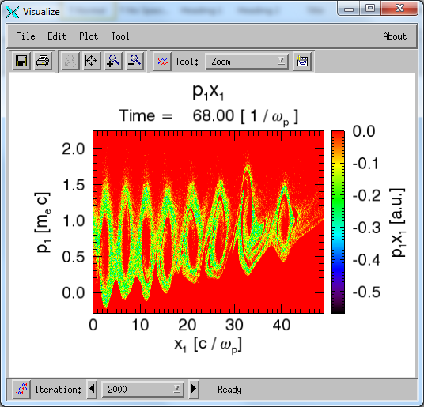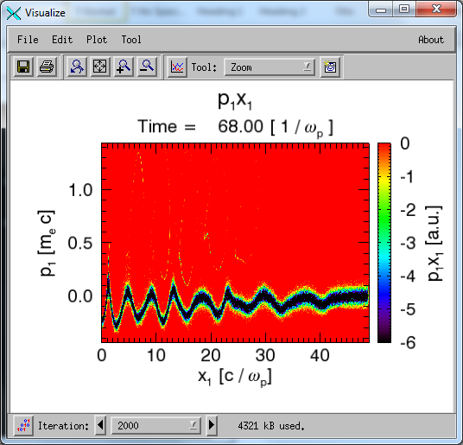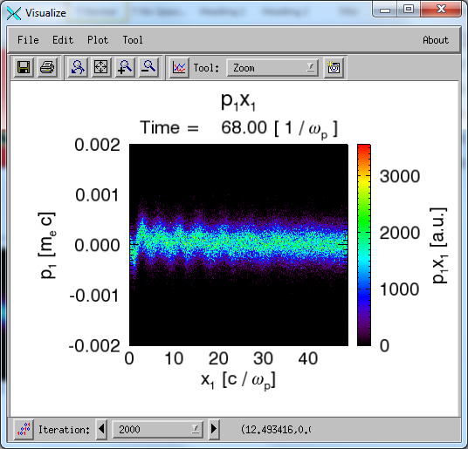
Figure 1a, b, c – Phase space plots of the beam electrons, plasma electrons and plasma ions, respectively, detailing behaviour chacteristic of the two-stream instability.

Figure 2 shows the electron beam trajectory in phase space at two distinct time frames where it is seen that the beam explodes and self-focusses along the direction of propagation. Initially it can be seen from figure 2a that the ability of the beam to re-focus itself is strong, however as the beam traverses further into the plasma it can be seen that the pinching effect begins to weaken resulting in an increase to the spot size of the beam, as seen in figure 2b. Strong filamentary behavior in the beam profile is also observed which is attributed to the Weibel mode as the oscillations perpendicular to the beam, associated with the filamentation instability, are known to saturate at much lower values [10]. The source of these beam filaments is further confirmed by the presence of a large number of small-scale, non-linear magnetic fields, synonymous with the excitation of the Weibel mode. The fine structure of these beam filaments is seen in the close up view detailed in figure 3a where widespread filamentation throughout the transverse profile of the beam is noted. Figure 3b is a more focused view of the leading edge of the beam, where it has traversed a considerable distance through the plasma slab, demonstrating that the beam is significantly depleted with only a small proportion of forward propagating radiation remaining. It is noted that although the beam has begun to collapse and the volume of forward propagating radiation has been significantly reduced, is it still capable of generating the two-stream like behavior. Further beyond the timestep corresponding to 36.40ω_{pe}⁻¹ the collapse is more apparent and the electron beam no longer has the energy to drive the instability leading to saturation of the process.

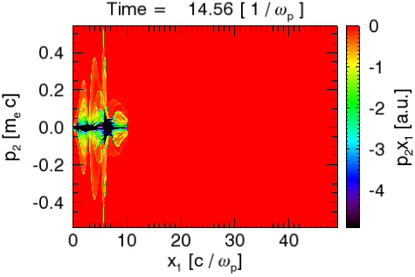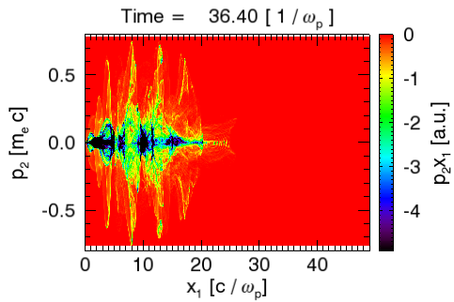
Figure 2a, b. Phase space plots of relativistic electron beam trajectory at t = 14.56 and 36.40 ω_{pe}¹.

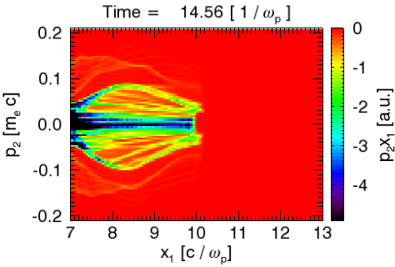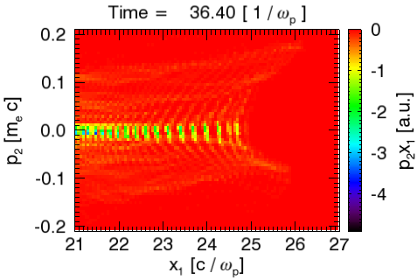
Figure 3a, b. Highlighted region of figures 1a and 1b, respectively.

The effect of including collisional processes into the analysis is observed upon comparison of figure 4 to figure 2. It is seen that the Weibel instability has been damped and the corresponding strong filamentary behavior associated with this instability within the beam structure has vanished. The damping of the Weibel mode negates any mode competition with the two-stream instability potentially allowing the electron beam to transfer a larger proportion of energy to the background plasma ion population. This is due to the fact that a larger proportion of the beam energy is directed on axis as required to create a hot spot for fusion ignition.

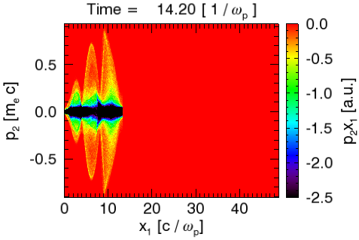
Figure 4 – Phase space plot of electron beam trajectory with collisional processes included.

In summary we have provided evidence to suggest that effective ion heating can be achieved in Fast Ignition ICF fusion plasmas through relaxation of the electron beam via the two-stream instability. The results from collisionless particle-in-cell simulations detail that the two-stream instability undergoes competition with the Weibel mode reducing the energy available for effective ion heating within the target plasma. By enabling collisions in the simulations it is seen that the Weibel mode can be preferentially damped enabling a larger proportion of the energy contained within the electron beam to be transferred to the plasma ion population, thus, providing an efficient route to achieving a hot spot for fusion ignition experiments. These results are important for a range of beam-plasma applications as it has been shown that the two-stream instability can be exploited effectively as an energy transfer mechansim, without suffereing detrimental effects from competing modes, via the inclusion of collisional processes into the numerical analysis.

Acknowledgements
The authors would like to thank the OSIRIS consortium for the use of OSIRIS and acknowledge support from CfFP. Simulations were carried out on the Scarf-Lexicon Cluster (STFC RAL).

References
[1] V. M. Malkin and N. J. Fisch, Phys. Rev. Lett. 89, 125004 (2002)
[2] C. Deutsch, Eur. Phys. Appl. Phys. 24 95-113 (2003)
[3] N. J Sircombe et al., Plasma Phys. Control. Fusion 50, 065005 (2008)
[4] J. T. Mendonca and R. Bingham Phys. Plasmas Vol.9, No.6 (2002)
[5] J. T Mendonca et al., Phys. Rev. Lett., 94, 245002 (2005)
[6] A. Bret et. al., Phys, Plasmas 12, 0872704 (2005)
[7] A. Bret et al., Phys. Rev, Lett, 100, 205008 (2008)
[8] R.A.Fonseca et al., LNCS 2331, (2002)
[9] M. H. Key, Phys. Plasmas 14, 055502, (2007)
[10] K. M. Watson et al., Phys. Fluids 3, 747 (1960)

