Image Simulations on the isis synchrotron
B.G. Pine, C.M. Warsop, ISIS, Rutherford Appleton Laboratory, STFC, Oxfordshire, UK.
Abstract
ISIS is the spallation neutron source at the Rutherford Appleton Laboratory in the UK. Operation centres on a loss-limited 50 Hz proton synchrotron, which accelerates ~3x10¹³ ppp from 70 to 800 MeV, corresponding to mean beam powers of 0.2 MW.
The ISIS synchrotron is of particular interest because of the rectangular, profiled aperture vacuum vessel, as compared with the more usual constant aperture circular or elliptical geometries. Off-centre beams resulting from closed orbit errors generate image fields, which influence the beam and may relate to loss mechanisms.
A new 2D space charge code, Set, was developed to study image-related behaviour. The code simulated space charge using a 2D particle-in-cell model of the beam distribution, including an appropriate treatment of the rectangular beam pipe, and details of the ISIS lattice. The effects of images on betatron tune and closed orbits were explored.

introduction
Medium energy, high intensity proton accelerators are required for a variety of purposes, for example as drivers for neutron spallation, inertial fusion or neutrino factories. The practical intensity limit on such accelerators is set by activation of machine components caused by beam loss. Understanding and controlling beam loss is therefore essential in order to optimize existing machines, and to build next generation facilities with much higher beam power.
The ISIS synchrotron has a history of high intensity, low loss operation. An important goal of the original design was to minimize the impact of space charge and beam instabilities.
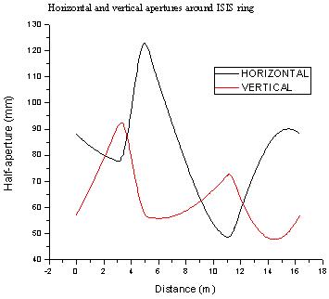
Figure 1: ISIS vacuum vessel aperture for one super-period.
One element of this design was the construction of the profiled vacuum vessel which varies with the transverse beam size as it passes through the magnetic focusing lattice (see Figure 1). Profiling of the chamber continues inside the magnets with the aid of RF screens. Most accelerators have constant aperture circular or elliptical vacuum vessels which are simpler and easier to construct.
ISIS is certainly a successful low loss design, but the role that image fields and vacuum chamber geometry play in this is not yet fully understood. A thorough examination of the role of images on ISIS is therefore planned to quantify the effectiveness of profiled vacuum vessels.

Simulation code
A simulation code, Set, was developed which tracked protons around a model of the ISIS synchrotron. Set used matrices to represent the linear focusing forces from the quadrupole lattice. At regular intervals non-linear self-field forces were calculated and applied to the beam, and these incorporated the image fields from the metallic vacuum vessel. In this way a model of the transverse dynamics of the beam was produced.
Due to the complex inter-relationship between the magnetic lattice and the self-field of the beam, analytical methods can only be taken so far, treating certain idealized situations. For a more complete investigation of realistic accelerator conditions, numerical techniques are required. 2D transverse dynamics were being studied, so no RF acceleration was included: the simulations represented a coasting unbunched beam at injection energy on ISIS (70 MeV).
Set was written in C++ and ran on a single processor, though a parallel version was in development. A bunch of macro-particles was used to represent the accelerated beam on ISIS, with 50,000+ macro-particles used to represent ~1 x10¹³ particles in the beam.
A transfer matrix model of the ISIS lattice was constructed for the tracking code, which used field measurements of the dipoles and quadrupoles in the ISIS ring to produce ideal magnet fields [1]. Work was underway to take input for the code from MAD-X [2] output. In order to describe fringe fields from the magnets accurately, the transfer matrices were not evenly distributed around the lattice. Near the edges of magnets there were several matrices, while longer drift spaces could be represented by only one matrix.
More elements were introduced to the lattice to represent space charge kicks. These were evenly spaced around the circumference to allow for easy computation of basic beam properties with azimuthal position or time. An FFT based Poisson solver was used to extract the beam’s potential.
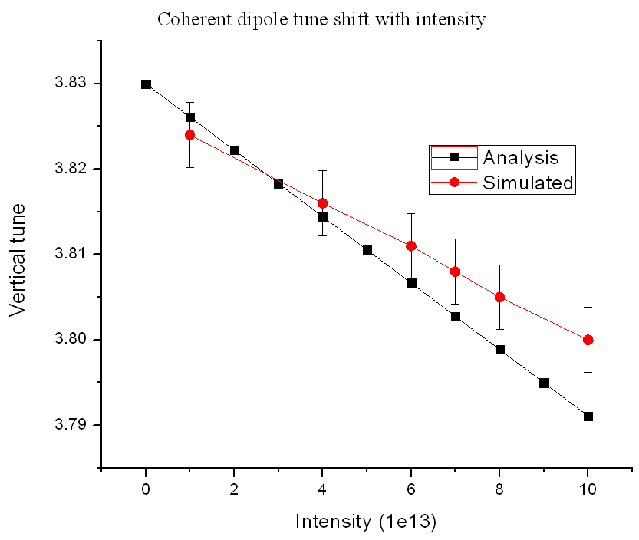
Figure 2: Analytical vs. simulated coherent tune shift with intensity.
Features of the tracker included periodic dipole magnet kicks to perturb the beam closed orbit and create image fields, and harmonic quadrupole errors to study envelope resonances. Set calculated root mean square position, velocity, envelope and emittance values from the whole bunch at every space charge lattice point around the ring. Full 4D particle data was also stored for selected particles throughout the run, which permitted the calculation of a sample of the beam’s incoherent frequencies and behaviour. More particles could have been stored, but this was limited by post-processing capabilities and storage constraints. A collaboration was in place with the e-Science Applications Group at Rutherford Appleton Laboratory to more efficiently examine patterns from the whole data set.

dipole tune image effects

Direct space charge should have no effect on the coherent dipole tune, because the charge distribution of the beam moves with the centre of charge. However it is predicted that image forces will affect the coherent tune, as the centre of charge does move relative to the vacuum vessel [3]:
${ΔQ}_{coh}=-\frac{Nr_{0}R}{π{γβ}^{2}ν_{0}}\frac{ε_{1}}{h^{2}}$
(1)
Where $ΔQ$ is the relative change in the dipole tune, N is the beam intensity, $r_{0}$ is the classical proton radius, R is the average radius of the synchrotron, $β$ and $γ$ are the relativistic factors, $ν_{0}$ is the nominal dipole tune, $ε_{1}$ is the Laslett image coefficient for parallel plate geometry and h is the vacuum vessel half aperture. This result was plotted in Figure 2, using ISIS parameters, but with 200 mm as the vacuum vessel half aperture, to match the Set simulation. As can be seen, there was reasonable agreement between the theory and Set results.

Intensity dependent closed orbit amplitude
The strongest image forces occur when the beam is displaced from the centre of the vacuum vessel. One way to achieve this is to kick the beam on every turn with a single dipole magnet. The beam will find a new closed orbit oscillating around the centre of the aperture, and image forces will be excited. However, the initial beam will be mismatched to the new closed orbit, and will then suffer from emittance dilution as it filaments in phase space. A new closed orbit injection point must be found. Therefore for each simulation result two runs were carried out: the first started with a centred beam, with no attempt to match the closed orbit, but did kick the beam every turn. By the end of that run the beam had “found” a stable closed orbit, and for the second run the beam was placed onto this closed orbit. It was found that 100 turns was enough time for this matching to be successful at the intensity levels considered for the simulations.
Linear theory predicts how the closed orbit at the kick location should be related to magnet kick amplitude [4]:

(a) | (b)
Figure 3: Closed orbit shift compared with dipole kick amplitude and intensity using 200 mm half apertures: (a) theory, (b) simulation.

(a) | (b)
Figure 4: Closed orbit shift compared with dipole kick amplitude and intensity using ISIS profiled apertures: (a) theory, (b) simulations.

$y_{CO}=\frac{β(s)×y'}{2×sin⁡(πQ)}$
(2)
Where $y_{CO}$ is the resulting closed orbit offset produced by kick $y'$, Q is the dipole tune and $β(s)$ is the Twiss beta function at position s around the ring. Equation (2) was used along with the values of Q predicted by Equation (1) to produce Figure 3a. Simulation results using a 70 MeV waterbag beam in a ±200 mm rectangular aperture are shown in Figure 3b. It was not expected that these results would match exactly: the theory is produced using a line charge representation of the beam, assuming only linear beam dynamics, whilst the simulations use a 4D water bag beam distribution in a linear lattice with non-linear space charge and image forces. However, the same general features are seen in both: a set of straight lines, gradient increasing with intensity, and the amplitudes are within a factor of two of each other. This is an indication that the simulation code Set is a good description of 2D beam dynamics on ISIS including image forces.
Calculations were also made using the average of the real profiled vacuum vessel aperture, and are compared with simulation results using the profiled aperture in Figure 4. The results match to within a factor of two as with the case above.

Conclusion
Work has begun investigating the effects of image forces on beam dynamics at ISIS. Simple analytical results for image dependent coherent tune depression and closed orbit offsets have been reproduced using the simulation code Set modelling the ISIS lattice. These results indicate that the analytical formulas give answers correct to within a factor of two, but further work is required to calculate in detail how the profiled vacuum vessel at ISIS impacts on high intensity operation. It will be crucial to calculate the relative importance of image forces when other factors like injection, longitudinal motion and instabilities are included in the simulations.

Future Developments
A rigorous investigation of the effects of images on beam dynamics at ISIS is planned, initially focusing on incoherent frequency shifts due to images, and their relation to the growth of resonances in the beam, and related beam loss. Such studies must also put image forces into context as part of a wider model of beam dynamics on ISIS.
A full program of experimental study is planned to compliment and confirm these simulation studies, including the development of new diagnostic tools for the ISIS synchrotron to allow measurements of image related effects.
Future development of the code includes the addition of a realistic injection scheme and longitudinal motion (including RF acceleration), before moving to full 3D simulation including field maps of the magnets and RF cavities.
Acknowledgements
Computing resources provided by STFC's e-Science facility.
Invaluable assistance provided to optimise the tracking code from e-Science Applications Group at Rutherford Appleton Laboratory.

References
[1] J. Rossbach, P. Schmuser, Basic Course on Accelerator Optics, Proceedings of Fifth General Accelerator Physics Course, CAS, 1992
[2] http://mad.web.cern/mad/
[3] K.Y. Ng, Physics of Intensity Dependent Beam Instabilities, 2006, p109
[4] E. Wilson, Transverse Beam Dynamics, Proceedings of Fifth General Accelerator Physics Course, CAS, 1992

