Operational experience with high beam powers at ISIS
D J S Findlay¹, ISIS, Rutherford Appleton Laboratory, STFC, Oxfordshire OX11 0QX, UK

Abstract
ISIS is currently the world’s most productive spallation neutron source. A total beam power of ~0.2 MW is delivered by a 70 MeV H– linac and an 800 MeV rapidly cycling proton synchrotron to two target stations, one which has been running since 1984, and a second which is being commissioned this year (2008). ISIS runs for typically ~200 days each year scheduled as some five ~40-day user cycles, although shutdowns lasting several months for major maintenance and upgrade work took place in 2002, 2004 and 2007 (during user cycles ISIS runs 7 days/week, 24 hours/day, and the ~200 days excludes run-up and machine physics time). In order to enable hands-on maintenance régimes to prevail, considerable efforts are made to minimise beam losses during operations, and engineering design of accelerator and beam line components specifically includes measures to limit radiation doses to personnel. This paper covers these issues and others — including the difficult balances to be struck between operations, maintenance and upgrade work.

INTRODUCTION
In terms of science output ISIS [1] is the world’s most productive spallation neutron facility, although PSI [2] and SNS [3] are more powerful spallation neutron sources, and also J-PARC [4] is now becoming operational. Hitherto at ISIS 180–200 µA of 800 MeV protons at 50 pps have been used to drive one neutron-producing tungsten target and one muon-producing intermediate graphite target. But a second target station (TS-2) has been constructed [5], also with a tungsten target (but without an intermediate target), and runs at 10 pps while the original target station (TS-1) runs at 40 pps. At the same time upgrades [6] have been carried out to ensure that when TS-2 becomes fully operational the mean beam current to TS-1 will not be less than it has been previously. Currently each year on average ~750 experiments are carried out involving ~1500 visitors who make a total of ~4500 visits. These numbers include ~100 experiments and ~300 visits for muons.
The key elements of the ISIS accelerator system are as follows: H– ion source at –35 kV, 665 keV 4-rod 202.5 MHz RFQ, 70 MeV 4-tank 202.5 MHz H– drift tube linac, 52 m diameter 800 MeV proton synchrotron with six 1.3–3.1 MHz fundamental RF ferrite-loaded cavities and four 2.6–6.2 MHz second harmonic ferrite-loaded cavities. The key elements of target systems are as follows: a tantalum-coated tungsten plate primary target with two water moderators, a ~100°K liquid methane moderator and a 20°K liquid hydrogen moderator for TS-1; and a tantalum-coated solid tungsten cylinder primary target with a coupled hydrogen / solid methane moderator and a decoupled solid methane moderator for TS-2. There are twenty-six beam line instruments on TS-1 (both neutron and muon instruments), Phase 1 of the instrument programme for TS-2 includes seven neutron beam line instruments, and an additional six or seven instruments for TS-2 are foreseen under Phase 2. A schematic layout of ISIS is shown as Figure 1.
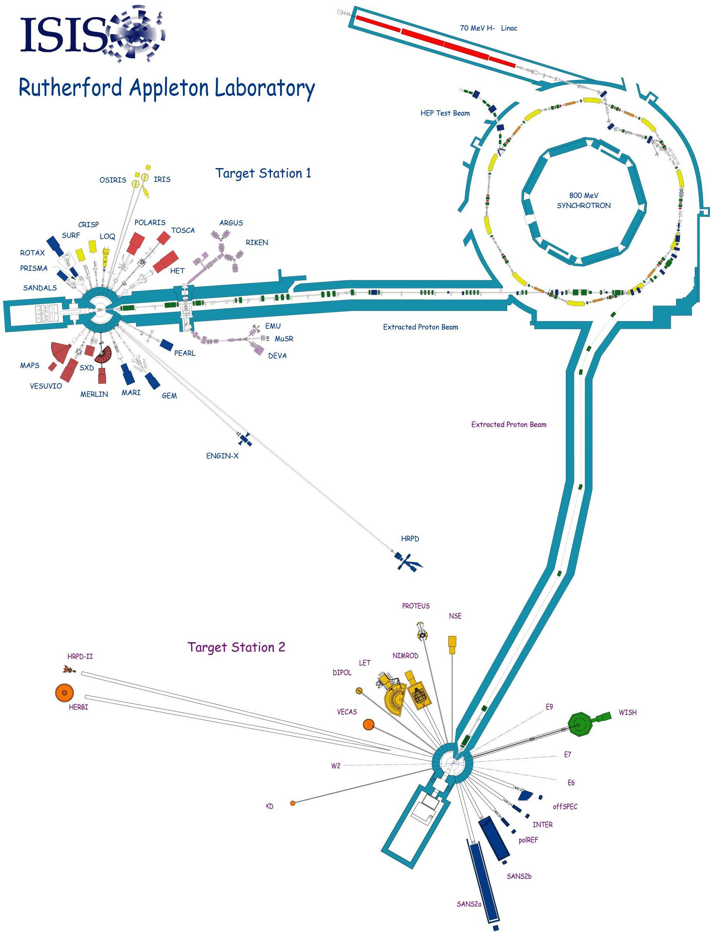Figure 1: ISIS schematic layout.

OPERATIONS
First beam on ISIS was on 16 December 1984. Thereafter, as seen in Figure 2, it took some 7–8 years for ISIS to reach the level at which it has since operated routinely. In the early days the ISIS synchrotron did not operate with its full complement of six (fundamental frequency) RF cavities but with only four, and the output energy was limited to ~550 MeV instead of the full 800 MeV. Since 1992, when ISIS output stabilised in terms of beam power, output in terms of science has increased by a factor ~20, at least as science measured in terms of volume of data produced and published, due to enhancements made to the suite of neutron instruments.
The ISIS running pattern is roughly as follows. Typically each year there are five sequences each made up as follows: maintenance and/or shutdown period;
~7–10 days for machine physics and run-up; ~40-day user cycle (operating twenty-four hours a day, seven days a week); ~3-day machine physics period. Because of problems encountered during shutdown/maintenance periods or as equipment is brought back on again, or because of problems encountered during user cycles, roughly one in every three machine physics periods is lost. Typically ISIS runs for 180 user-days a year; it is reckoned that 220 days is the maximum that could be tolerated without making a major increase in the resources available to ISIS.
ISIS is also host to MICE [7], an important step on the road to a practical neutrino factory.

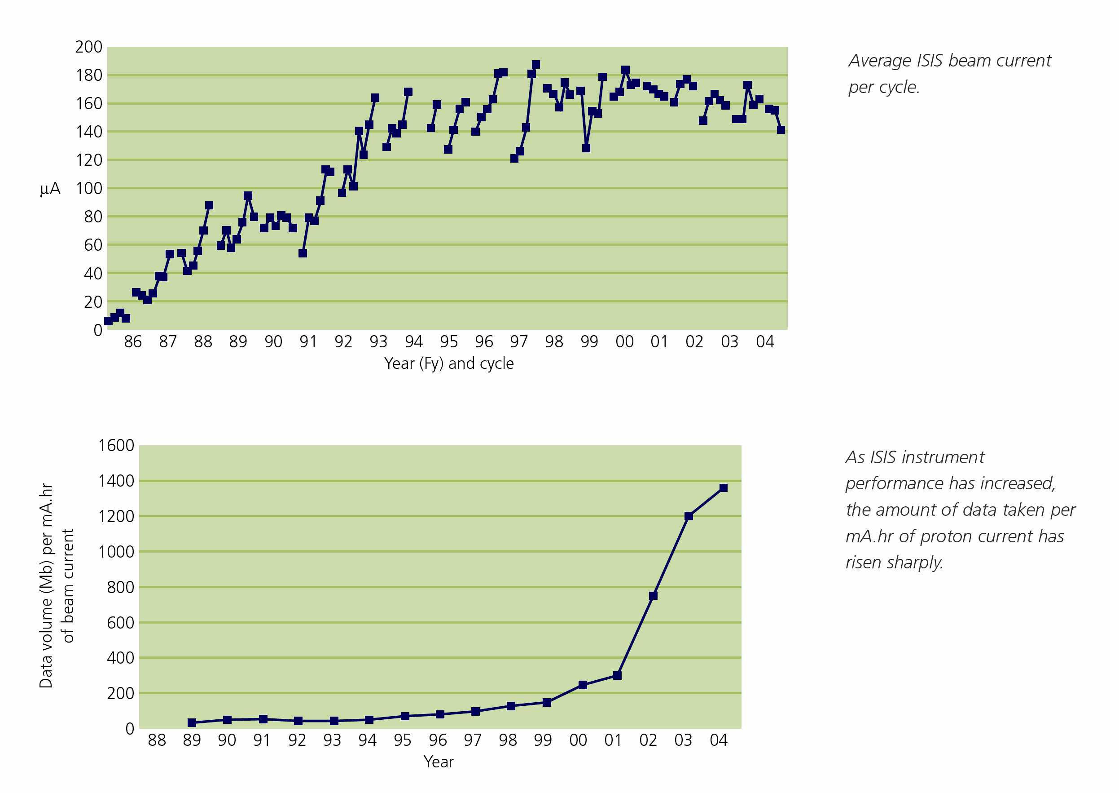
Figure 2: ISIS output between 1985 and 2005. The upper plot shows the mean beam current during each ~30–50-day user cycle. Note that the numbers plotted are the mean beam currents averaged over the total duration of the cycle — average beam currents when the beam was on would be typically 10–15% higher.
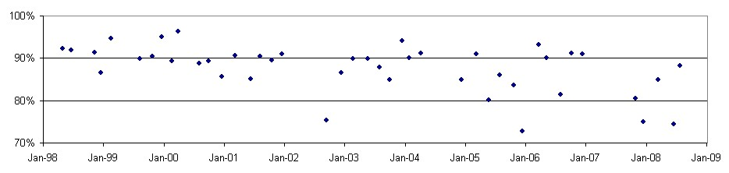
Figure 3: Availabilities of ISIS cycles over the last ~10 years.

Operationally, ISIS is run by a Crew made up of five teams of four people, and even during extended shutdowns when the numbers of people in the evening and night shift teams may be reduced, the Crew is on shift 24 hours a day, 365 days a year. Each shift team is made up of a Duty Officer, an Assistant Duty Officer, a Shift Technician and an Operations Assistant. Outside normal office hours the Duty Officer is responsible for all operations on his shift, including user operations. To back up operations there is a team of health physicists, one of whom is on call outside normal office hours. In addition, there are ~30 people on call for the accelerator and target and ~15 for the neutron instruments and sample and environment support who can be called in at any hour of the day or night to help resolve problems.
Figure 3 shows the availabilities achieved by ISIS during user cycles over the past ~10 years. The average availability is 88%, and the numbers are distributed with a standard deviation of ±6%. It may be noted that for individual cycles availabilities greater than ~95% have never been achieved. The distribution of lengths of trips making up the 12% non-availability over the past ~10 years is shown in Table 1.
Trips longer than | Average number of trips per day | Standard deviation
1 second | 28 | 18
1 hour | 0.44 | 0.13
3 hours | 0.20 | 0.08
6 hours | 0.09 | 0.07
Table 1. Numbers of trips contributing to ISIS non-availability.
Figure 4 shows the causes of the non-availability of the ISIS facility over the last 4–5 years — distributed over twelve categories (it should be noted that there is always a degree of arbitrariness about such representations). It is clear that there is no one major cause of faults.
One possible interpretation of the pie-chart in Figure 4 may be that it is the power systems with relatively large ratios of peak power to mean power that are the most unreliable. For example, the ion source, linac RF, and extraction/injection systems are the most “peaky” of the systems in the pie-chart, and they are the least reliable, and the linac RF systems are more “peaky” and less reliable than the synchrotron RF systems. But, of course, resources to maintain operations should not necessarily be assigned to systems in proportion to the sizes of the corresponding sectors, as overall risks to operations depend on consequences as well as likelihoods.
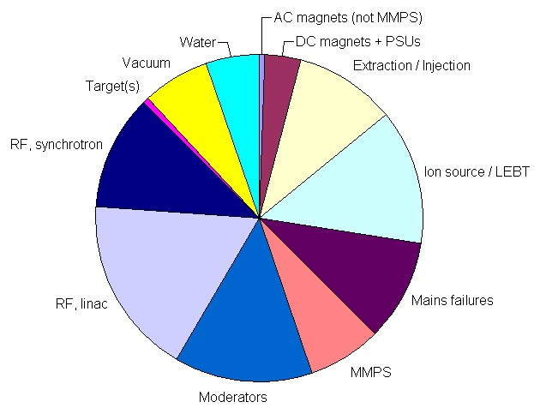
Figure 4: Causes of ISIS downtime, 2004–2008.
It may be observed that time lost due to problems with the mains electricity supply is not negligible. While efforts have been made to mitigate the problem as far as key systems of modest power are concerned through the installation of uninterruptible power supplies (UPSs), it is not easily possible to provide a UPS for all of ISIS (~10 MW power consumption with TS-1 alone, and
~12–13 MW with the addition of TS-2).

BEAM LOSSES, RADIATION DOSES and engineering design
As at many accelerator installations, an important requirement at ISIS is to minimise radiation doses to personnel. While in general the legal annual limit for radiation doses to people in the UK is 20 mSv, the formal investigation level at the Rutherford Appleton Laboratory (RAL) is 6 mSv, and dose constraints of 2–3 mSv have been set. Annual collective radiation doses are typically ~50–100 mSv for the ~300 ISIS staff who wear radiation badges. Clearly it is very important to reduce beam losses as much as reasonably possible in order to minimise dose to maintenance workers, but it is also equally important for engineering design of hardware to take into account radiation doses to people from the outset — dose rates per se are much less important than annual doses to people.
On ISIS, in areas where significant activation may be expected, quick-release vacuum seals, special-purpose long-reach tools, quick-release latches, pre-aligned assemblies, special lifting cradles, and configurable local shielding assemblies are used — all consistent with the three traditional health physics dose-reducing measures of time, distance and shielding. Figure 5 shows an ion pump assembly on the synchrotron where quick-release vacuum seals, quick-release latches, lifting lugs for lifting cradles, and alignment rails for accepting an assembly pre-aligned off-line can be seen.
Typical radiation dose rates on accelerator components which are not specifically designed to be irradiated but which in practice become “active” during operations are very roughly ~1 mSv/h on contact or ~100 µSv/h at 0.5 m, although maximum values are very roughly ~10 mSv/h and ~1 mSv/h respectively. The most radioactive accelerator components are the collectors in the synchrotron extraction straight where dose rates are very roughly ~10 mSv/h at 0.5 m, but the extraction straight is shielded by 0.6 m thick walls of concrete blocks.
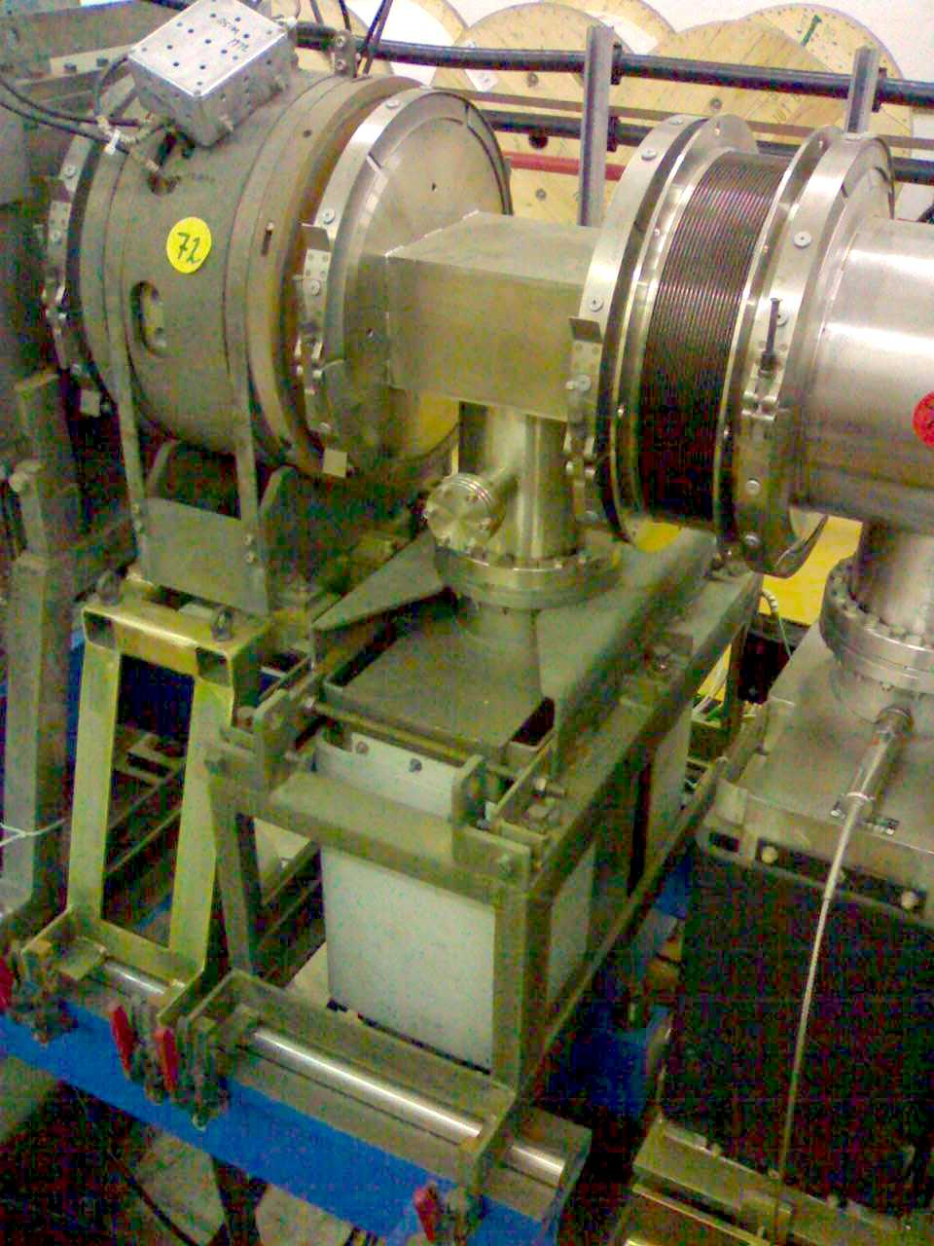
Figure 5: An ion pump assembly on the ISIS synchrotron showing various features outlined in the text to minimise radiation doses to maintenance workers.
Beam losses on ISIS amount to ~1 kW, mostly at the collectors in Straight 1 of the synchrotron, and mostly due to trapping losses. An “equivalent” loss rate per metre of ~6 W/m is obtained upon dividing by the 163 m circumference of the synchrotron — a value which in view of the relatively low energies (~100 MeV) at which the beam losses occur may not be too different from the traditional figure of 1 W/m at higher energies. It may be worthwhile noting that while the ISIS beam power of ~0.2 MW is relatively modest, if the beam losses around ISIS were twice as great as they actually are there would be significant difficulty in complying with the dose constraints.
Operationally, the most important diagnostics on ISIS are the beam loss monitors (BLMs), in particular the forty BLMs distributed around the synchrotron, four to each of the ten superperiods. It is a sine qua non at ISIS that the beam trip thresholds on the BLMs are never increased. The calibration (after amplification) of the BLMs (argon ionisation chambers) is roughly 4×10^{–5} E² femto-volt-seconds per proton of energy E lost (where E is in MeV), and the BLMs are described in more detail elsewhere [8].

MAINTENANCE RÉGIMES
It may be worth noting that the availabilities in Figure 3, good or bad as they are, are achieved only because significant maintenance work is carried out during time outside time scheduled for operations, and so the availability numbers given above cannot be assumed to be representative of an accelerator facility intended to be run continuously. In principle a “just-in-time” preventative maintenance régime is followed on ISIS, but, in practice, perhaps inevitably, a “responsive mode” régime usually prevails.
It is ISIS practice to hold as many spares as reasonably possible, and this runs to the extent of holding a complete spare RFQ for the operational 665 keV 4-rod RFQ installed immediately before Tank 1 of the 70 MeV H– linac. Explicit account has to be taken of the long procurement times for spare vacuum tubes (Burle 4616 tetrodes for the intermediate amplifier stages in the linac RF systems, Thales TH116 triodes for the power amplifier stages in the linac RF systems, and Burle 4648 tetrodes for the power amplifier stages in the synchrotron RF systems) and of the effects of a decreasing customer base world-wide for these tubes.
Cooling times before maintenance or repair work can begin depend very much on where the work is to be carried out. But in general two hours are allowed to elapse before personnel enter high radiation areas, and after a typical user cycle two weeks are allowed to elapse before major work is undertaken in the synchrotron room.
ISIS is fortunate in that the present synchrotron was built in the hall originally constructed for the old Nimrod 7 GeV proton synchrotron, and that the Nimrod synchrotron was a weak-focussing machine with large apertures. As a result there is ample space above and around the present ISIS synchrotron for major work to be carried out, and three overhead cranes (5, 30 and 45 tons lifting capacities) are available.
Radiation-induced chemical reactions in the liquid methane flowing through the TS-1 liquid methane moderator eventually lead to partial blockages of the flow channels. Consequently the methane moderator has to be changed every ~100 full-power days. Three weeks are usually scheduled for each methane moderator change.
Maintenance is usually carried out in ~1-month-long shutdowns, but major maintenance work, and also major upgrade work, tends to be carried out in shutdowns several months long. Experience suggests that one week of start-up time be scheduled for every month off.

COMMISSIONING EXPERIENCE
Most recent commissioning experience at ISIS has been of commissioning new equipment on an operating machine — which has posed considerable problems. In practice every effort has had to be made to prevent time to repair faults from eating into time scheduled for users, and so development and commissioning time is eaten into instead. This has been particularly significant for commissioning the second harmonic RF system [9] for the synchrotron — a great deal of commissioning time has had to be sacrificed.
It has proved very useful to set up, where possible, off-line commissioning rigs. For example, a test stand [10] was set up for the present RFQ before it was substituted for the ageing Cockcroft-Walton preinjector, and in practice the test stand proved invaluable in uncovering issues that would have proved embarrassing had they occurred for the first time after installation of the RFQ on ISIS. An off-line conditioning rig for the Burle 4616 tetrodes used in the intermediate amplifier stages in the linac RF systems has been in use for many years, and a new synchrotron RF development laboratory currently being set up will include a conditioning rig for the Burle 4648 tetrodes used in the power amplifier stages in the synchrotron RF systems.
The latest commissioning exercise at ISIS is the commissioning of the new Second Target Station, and substantial complications have arisen over the need to preserve the schedule of TS-1 operations for users. However, an account of the commissioning process will be given later elsewhere.

OBSOLESCENCE MITIGATION
After it has been operating for several years, the equipment in any large accelerator facility gradually becomes obsolete, and ISIS is no exception. Most of the equipment in ISIS has been running for ~25 years, and some of the equipment was already second-hand when ISIS was built. Accordingly ISIS has embarked on an obsolescence mitigation programme which began ~8–9 years ago and is currently running at an annual rate of ~10% of the current total operating costs.
Work already carried out or being carried out under the programme includes replacement of the synchrotron ~1–2 MVA main magnet power supply, replacement of the ageing Cockcroft-Walton preinjector by an RFQ, installation of new extraction fast kicker drivers, installation of modern anode power supplies for the linac and synchrotron RF systems, refurbishment of the synchrotron extraction straight, installation of a new machine interlock system (to the IEC 61508 standard), replacement of ageing water plant, replacement of old injection and extraction power supplies, replacement of ageing trim quadrupole power supplies, and installation of new mains electricity distribution systems. The largest exercises were carried out in long (~6-month) shutdowns in 2002, 2004 and 2007, and another long shutdown is planned for 2010 or 2011. Planning for these long shutdowns typically begins at least two years in advance, and substantial effort is put into project-managing the shutdowns.

UPGRADES
Plans for megawatt-scale upgrades to ISIS have been under development for several years. Perhaps the most attractive of the upgrades involves the addition of a ~3 GeV synchrotron to the present 800 MeV synchrotron with bucket-to-bucket transfer from the lower to the higher energy synchrotron. However, a much fuller description of ISIS upgrade options is given in [11].

FINALE
ISIS has now been running for 23 years, and with TS-2 is fully expected to run for at least another ~15 years. It is perfectly possible that a megawatt upgrade would lead to operation up to and beyond the year ~2030.

References
[1] http://www.isis.rl.ac.uk/.
[2] http://www.psi.ch/.
[3] http://neutrons.ornl.gov/.
[4] http://j-parc.jp/.
[5] http://ts-2.isis.rl.ac.uk/.
[6] J W G Thomason, Upgrades to ISIS for the New Second Target Station, Proc. Euro. Part. Accel. Conf. (EPAC), Genoa, 2008, p 2902.
[7] M S Zisman, Status of the International Muon Ionisation Cooling Experiment (MICE), Proc. Part. Accel. Conf. (PAC), Albuquerque, 2007, p 2996.
[8] S J Payne, Beam Diagnostics at ISIS, 42nd Advanced Beam Dynamics Workshop on High Intensity, High Brightness Hadron Beams (HB2008), Nashville, Aug. 2008.
[9] A Seville et al., Progress on Dual Harmonic Acceleration on the ISIS Synchrotron, EPAC-08, p 349.
[10] A P Letchford et al., Testing, Installation, Commissioning and First Operation of the ISIS RFQ Pre-injector Upgrade, PAC-05, p 695.
[11] J W G Thomason, Megawatt Upgrades for the ISIS Facility, HB2008.

¹ While the named author may have written this particular paper, all the work it summarises has been carried out by others, including D J Adams, G M Allen, M A Arnold, D L Bayley, R Brodie, R A Burridge, T E Carter, J D Christie, M A Clarke-Gayther, M B Davies, D C Faircloth, I S K Gardner, M G Glover, J A C Govans, N D Grafton, J W Gray, D J Haynes, S Hughes, T Izzard, B Jones, H J Jones, M Keelan, A H Kershaw, M Krendler, C R Lambourne, A P Letchford, J P Loughrey, E J McCarron, A J McFarland, R P Mannix, A J Nobbs, T Noone, S Patel, S J Payne, L J Pearce, M Perkins, G J Perry, L J Randall, M J Ruddle, S J Ruddle, I Scaife, A M Scott, A Seville, A F Stevens, J W G Thomason, J A Vickers, S Warner, C M Warsop, P N M Wright. The author takes full responsibility for any misrepresentation of the work of the aforementioned. ? On average, very roughly, each visitor visits ISIS three times a year.
In the spring of 2008 the size of the Crew teams was increased from three to four, to accommodate the extra duties imposed by the running of TS-2 and to enable the Duty Officer (the leader of each Crew team) to interact more fully with the users.
This number will be increased as more and more instruments on TS-2 are brought into operation.
For example, should the failure of an RF window in a linac tank be categorised as an RF or as a vacuum failure?
For example, the ISIS “worst case scenario” is failure of a ~100-ton ~40-year-old oil-filled choke at the heart of the synchrotron main magnet power supply (MMPS). A substantial programme has been set up to mitigate this risk.
For example, thermionic vacuum tube heater characteristics are monitored with a view to predicting ends of useful lives and if necessary replacing tubes prior to the cycle in which they are expected to fail.
Which delivered beam for high energy physics experiments at the Rutherford Laboratory between 1964 and 1978.
First neutrons from TS-2 were produced on 3 August 2008, and first operation of TS-2 at 10 pps was achieved on 18 September 2008.
The oldest components on ISIS are probably the second and third tanks of the four-tank 70 MeV linac which were originally built in 1955 by Metropolitan-Vickers for the 50 MeV Proton Linear Accelerator (PLA).
On a heavily committed user facility such as ISIS long shutdowns simply cannot be scheduled often. In practice, to avoid upsetting the user community, at least two years must be allowed to elapse between long shutdowns.

