Long-term preservation for INSPIRE: a metadata framework and geo-portal implementation

Arif Shaon¹ (arif.shaon@stfc.ac.uk), Andrew Woolf¹ (andrew.woolf@stfc.ac.uk)
¹STFC e-Science centre, Rutherford Appleton Laboratory, Harwell, UK

1. Introduction
The INSPIRE directive aims to develop a pan-European spatial data infrastructure (SDI) in order to enable efficient discovery and uniform accessibility of environmental data across Europe. To ensure this level of interoperability, the directive mandates the adoption of common Implementing Rules for metadata, data specifications, network services, and sharing and monitoring of data. While this is an effective way of ensuring interoperability across disparate datasets, it does not guarantee sustainability of those datasets over an indefinite period of time (e.g. compatibility with future technology or ensuring continued access even after a provider has ceased to exist); interoperability’s scope must extend to the temporal dimension.

Sustained access to environmental data is becoming increasingly important and difficult, especially in light of its growing volume (e.g. satellite Earth observation (EO) data can grow at rates of terabytes per day; Janée et al., 2008). Historical geospatial data is also increasing in value for monitoring and analyzing social, environmental (e.g. global climate change) and economic changes (McGarva et al., 2009) that occur over time.

Without effective long-term preservation, environmental data face the risk of becoming unusable over time. From this perspective, there is a pressing need for the long-term preservation of the data made available through INSPIRE. In this paper, we investigate the requirements for developing a preservation-aware SDI based on the OAIS reference model, a widely adopted ISO standard for digital preservation. In addition, we present an implementation approach in the form of a Geo-Portal that incorporates a preservation profile of the ISO 19115 metadata standard.

2. The Main Challenges of Preserving Environmental Information
In general, environmental data inherit the preservation challenges inherent to all digital information (McGarva et al., 2009). These challenges are further complicated by some of the unique characteristics of environmental datasets, such as diverse data formats, highly structured and the need for special knowledge for accurate interpretation. Moreover, the emergence of geospatial web services (e.g. OGC services) further adds to these challenges, as static data are replaced by dynamic and changing services (Morris, 2006). For instance, state-of-the-art service-oriented infrastructures adopt exchange formats that reflect conceptual data models (‘feature types’) rather than the underlying database-specific storage schemas.
On the positive side, it appears possible, in principle, to apply existing widely adopted preservation mechanisms and standards, such as the OAIS reference model to the long-term preservation of geospatial data. And Web service technologies enable harmonized and interoperable accessibility of data, which may be useful for developing effective long-term preservation approaches for geospatial data based on these existing approaches.

3. A Preservation-aware Spatial Data Infrastructure
We analysed the INSPIRE architecture with a view to determining the requirements for a preservation-aware SDI. INSPIRE consists functionally of a number of Geospatial Data repositories, Metadata catalogues, Geo-processing web services (to enable analysis and processing of data) and User applications (client software to search metadata catalogues and locate particular dataset(s) for access or further processing as required) (Figure 1).

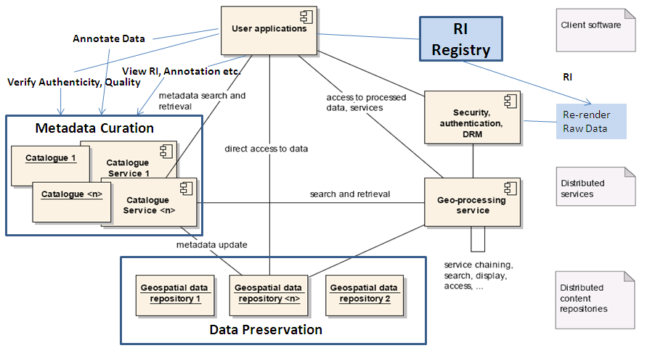
Figure 1: A Preservation-aware SDI

The main focus of the INSPIRE SDI is to facilitate uniform data discovery, access and processing across the entire SDI. While uniform discovery of data is achieved by harmonizing different dataset descriptions through a common metadata model (i.e. ISO 19115), implementation of various OGC standardized web service specifications (e.g. for download and viewing) provides interoperability between different network services (including geo-processing).

An analysis of the applicability of the OAIS reference model to the INSPIRE SDI identifies three core requirements for ensuring sustained accessibility and usability of the SDI data:
  - Long-term preservation of geospatial data repositories
An effective and coherent approach is required to preserve the data repositories made available through the SDI over the long-term. This preservation approach will need to address various complex issues, such as compatibility of data with future technology and ensuring its continued access even after its provider has ceased to exist. This aspect is not dealt with further here.
  - Preservation Metadata
The ISO 19115 metadata model adopted in the INSPIRE SDI does a commendable job at capturing enough of the context surrounding data (e.g. data quality, maintenance, use/processing) to enable its effective discovery. However, the metadata elements defined in ISO 19115 do not capture important preservation-related information, such as technical dependencies (e.g. data formats, rendering application), detailed provenance and versioning history, and annotation. Also of particular importance is the mapping between a source geospatial data set and its corresponding application schema to represent particular facets of phenomena on the earth as features that are exposed by INSPIRE (e.g. a pan-European road network). Without these types of information, accurate interpretation and re-use of the geospatial data on a future technological platform may not be possible.
  - Long-term curation of metadata catalogues
The metadata catalogues are instrumental in facilitating searching of the metadata that describe the datasets held in the repositories. As mentioned above, a preservation-aware metadata model would enable capturing sufficient information about a dataset to facilitate its effective long-term preservation. However, without proper management, quality assurance and preservation (i.e. curation), the metadata too may become unusable over time, as, for example, they may become out of step with the data they describe. Therefore, it is also crucial to apply effective long-term curation measures to the metadata catalogues within an SDI.

4. A Preservation profile of the ISO 19115 Metadata model
As indentified above, the ISO 19115 metadata model is not sufficient to capture the information needed to enable accurate interpretation of geospatial data in the future. Therefore, we have developed a preservation profile of ISO 19115 based on the metadata requirements specified in the OAIS reference model and the PREMIS data dictionary, an OAIS-based preservation metadata model. This profile is intended to enable recording preservation-related information about a geospatial dataset, while retaining the ability of the core ISO 19115 model to capture descriptive and contextual metadata about that dataset. The preservation profile incorporates the following key preservation concepts into the core ISO 19115 model (Figure 2):
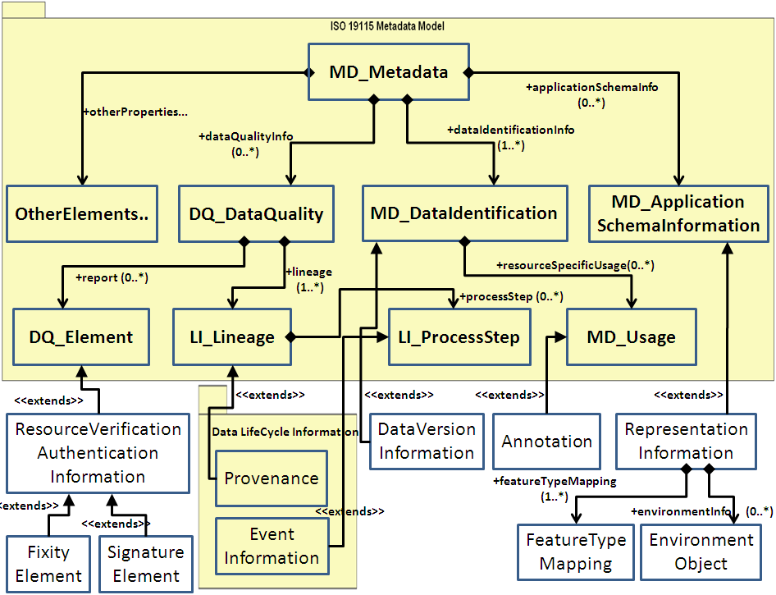

Figure 2: A preservation profile of ISO 19115 Metadata Model

- Representation Information: to enable accurate rendering and proper (re-)use of data in the future. This includes information about the mappings between a source dataset and its corresponding feature view(s).
- Data Life-cycle Information: preservation-related changes and events occurring during the life-cycle of a dataset; essential for verifying the provenance of a dataset as well as the reliability of its preservation in the future.
- Data Authenticity Verification Information: (e.g. checksum and digital signature) needed to identify unauthorized alterations to a dataset.
- Annotation: related information that may add value to a dataset.

5. Implementation of a Preservation-aware SDI
We have implemented a web-based portal that demonstrates the underlying functions of a preservation-aware SDI. In general, this portal implements the main features of a community geo-portal as implied by the INSPIRE directive, such as data discovery using geospatial metadata, data downloading, metadata creation and validation and so on. The preservation focused geo-portal adds to these features the ability to annotate data and metadata, track different versions of a metadata record, and view preservation related information about a dataset, such as representation information and preservation history. This demonstrates the feasibility of providing users with the information needed to locate and use a dataset along with assessing its quality, integrity and long-term preservation; or even potentially recreating an INSPIRE-conformant dataset in the future from source if necessary, through a web-based, easy-to-use system. The portal uses the aforementioned preservation profile of ISO 19115 as the underlying metadata format for describing the datasets that it provides access to.

The implementation of this geo-portal is based on GeoNetwork, an open source and standards-based catalogue service that is widely adopted within the geospatial community for managing and sharing geospatial resources on the web.

6. Conclusions and Future Direction
Long-term preservation of the environmental data exposed through uniform and interoperable SDIs is not currently addressed in the INSPIRE directive but highly important for applications that require continued access to both current and historical data for e.g. monitoring climate change. The work presented in this paper investigates the requirements for ensuring sustained access to environmental data from the perspective of a preservation-aware and INSPIRE-conformant SDI. In addition, the work demonstrates an approach to implementing such an SDI, providing the information needed to assess the quality, integrity and long-term preservation of data, as well as ensuring its effective discovery and use.

Future work in this area would need to focus on the implementation of efficient and interoperable preservation solutions for the data repositories made available through the INSPIRE SDIs. In particular, this should include preserving mappings (potentially with varying levels of complexity) between a source dataset and its corresponding feature view(s) to enable accurate recreation of those feature views in the future. The emerging ESA LTDP initiative is expected to make significant contributions to this area as it aims to formulate a coordinated and coherent approach to the long-term preservation of EO space data archives across the European Union. The work presented in this paper may also be seen as an exploratory exercise for this ESA initiative.

References

Greg Janée, Justin Mathena, & James Frew (2008): A Data Model and Architecture for Long-term Preservation. Proceedings of the 8th ACM/IEEE-CS Joint Conference on Digital Libraries (JCDL) (Pittsburgh, PA; June 16–20, 2008):134–144. doi:10.1145/1378889.1378912 - www.ngda.org/research/Tech%20Arch/jcdl-paper.pdf

Guy McGarva, Steve Morris & Greg Janée (2008): Preserving Geospatial Data, Technology Watch Report, Digital Preservation Coalition (DPC), DPC Technology Watch Series Report 09-01 - http://www.dpconline.org/technology-watch-reports/download-document/363-preserving-geospatial-data-by-guy-mcgarva-steve-morris-and-gred-greg-janee.html

S. P. Morris (2006): Geospatial Web services and geoarchiving: New opportunities and challenges in geographic information services. Library Trends, 55, pp. 285-303. - www.lib.ncsu.edu/ncgdap/documents/MorrisLibraryTrendsFall2006.pdf

INSPIRE Directive - http://inspire.jrc.ec.europa.eu/
Open Archival Information System (OAIS) Reference Model - http://public.ccsds.org/publications/archive/650x0b1.pdf
Open Geospatial Consortium (OGC) Web Services Specifications - http://www.opengeospatial.org/standards
PREMIS Data Dictionary - http://www.loc.gov/standards/premis/v2/premis-2-0.pdf
GeoNetwork - http://geonetwork-opensource.org/
European Space Science (ESA) Long-term Digital Preservation (LTDP) Programme - http://www.digitalpreservationeurope.eu/publications/briefs/dp_for_longterm_environmental_monitoring.pdf

