Some Tools for Supporting SRB Production Services
R. Downing
CCLRC-Daresbury Laboratory

- Weise, C. Koebernick
University of Reading

- Hasan
CCLRC-Rutherford Appleton Laboratory

Abstract*
Providing production-level services requires monitoring applications, performance and intercepting errors as soon as they occur. In this paper we describe some of the tools that have been developed to assist production SRB services. We describe the approaches used and how they can be more generally applied.

Introduction
The Data Management Group (DMG)[1] is part of the Council for the Central Laboratory of the Research Councils (CCLRC) e-science centre [2] and provides data storage solutions for a large number of e-science projects. The DMG uses the Storage Resource Broker (SRB) [3] as the core component for many projects, tailoring the system to meet the needs of the project. Once a system is deployed the DMG also provides a level of support for the service ranging from troubleshooting to responding to further feature requests and upgrades.
Through the course of developing various SRB systems we have managed to identify a number of tasks that appear common and which greatly help in supporting a production system. In this paper we describe a few of the tools developed to aid this task.

Monitoring Production Servers
Careful monitoring of production servers provides a number of benefits: aids debugging, provides information on the distribution of load in the system and provides information for planning purposes. Troubleshooting and load balancing require both instantaneous information and also historic information whereas planning requires only historic information.

Ganglia and Nagios Monitoring
Since the SRB system is distributed any monitoring application must be capable of working with distributed systems. With this requirement in mind we have selected Nagios [4] to report instantaneous information on server properties, such as cpu, machine load, etc. The Nagios system emails a list of subscribers when any of the monitored properties of a server go beyond an acceptable threshold limit as well as reporting when a server is down.
For the collection of historic information we chose Ganglia [5]. The Ganglia monitoring system collects a set of system properties at regular intervals and stores them in a round-robin database. It is also possible to monitor additional properties by providing a script to extract these properties to Ganglia. The system also provides tools for presenting the information as a series of web-pages (see figure 1). As we run more than one SRB server on a given host we needed to make a minor kludge to allow the same host to appear in more than one group.
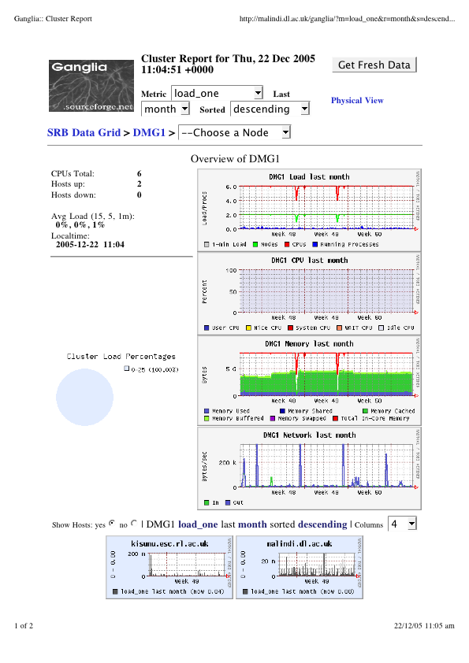
Figure 1: Ganglia web page displaying usage for a test SRB server.

Monitoring SRB Server Log Files
Each SRB server writes activity information to a log file. These log files contain information about which process, and from which machine, connected to the SRB server as well as error messages detected by the server when handling a request. These error messages along with the time that they occurred are an essential tool in troubleshooting. It is important to notify administrators as soon as an error occurs, it is also important to log the error messages in order to identify chronic problems and possibly identify patterns.
Any application to monitor the log files would need to be able to parse the log files for error messages, email to a subscriber list serious errors and collect in a central location the error messages for later searches. With these requirements we decided to build a system in Python to parse, log and notify when error messages occurred [6].
It is possible that Ganglia could be used to parse the log files and store the resulting error messages in a central round-robin database, but we found that the database was not flexible enough for our queries and we also required email notification when problems occurred.
The system essentially consists of three components: a Parser a Collector and a Displayer, figure 1 shows a simple diagram of how the application works.
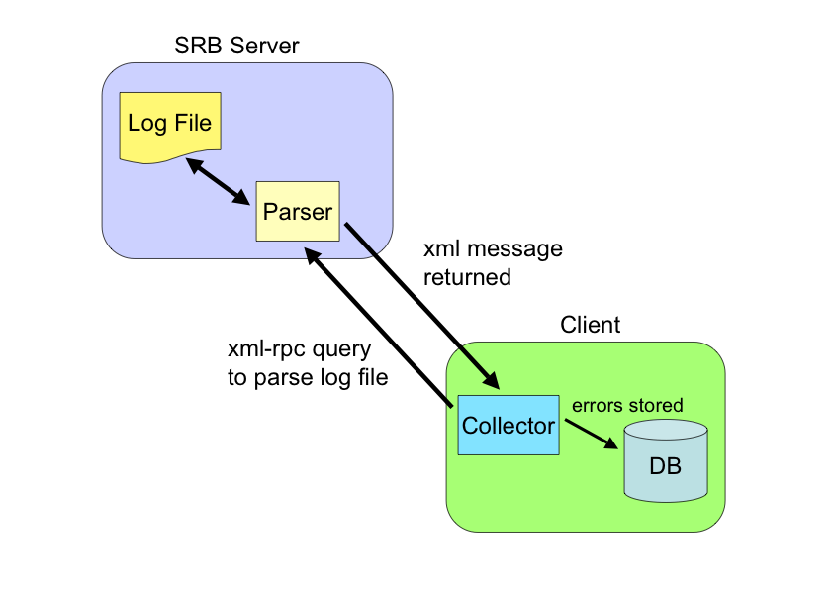
Figure 2: A simple schematic showing the log file parser system.

The Parser is actually an XML-RPC server that is started on the SRB server host and consists of a method to parse the SRB log file. The Collector is a daemon that sends an XML-RPC message to the Parser to parse the log file. The parser then returns an XML message containing the error message, line number, date, server and error message code to the Collector. The Collector then extracts the information from the XML message and stores the contents in an SQLite database and sends an email containing the error message information to a list of subscribers. The list of SRB servers that the Collector should contact and the frequency with which to contact them is read from a configuration file.
The Displayer is used to graphically display the error messages as a function of server that can help in identifying potentially chronic problems with a server. The Displayer can also plot error messages of a particular type as a function of time that may reveal interesting patterns that could help troubleshooting. Figure 2 shows a screenshot of a histogram of error messages for a given server.

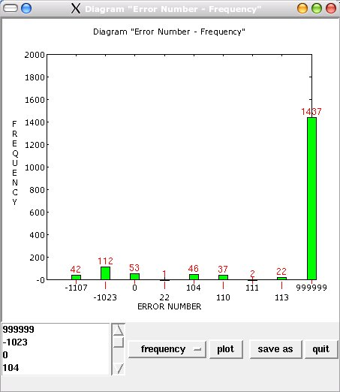

Figure 3: Screenshot of the error message numbers extracted from an SRB log file.

The numbers above the bars correspond to the actual occurrences of errors with that error number and error number 999999 corresponds to messages that do not have an SRB defined error number.
The Parser assumes all messages are error messages unless the user specifies in a configuration file a pattern contained in messages that should be ignored. The approach of assuming every message is an error ensures that we do not accidentally miss an unusual error message.

Tools for Measuring Performance
Measuring the performance of a system is important as it helps to determine the capabilities of the system, it helps to determine bottlenecks in the system and it provides a means of tuning a system. We have developed a framework that can be used to run performance tests [7] and a number of scripts that execute performance tests using Scommands on an SRB system.
The framework consists of the Ganglia monitoring system to monitor the SRB server and client application, an SQLite database to hold the measurements and Collector collect the results from Ganglia and store them in the SQLite database. The framework can also display, in real-time, graphs of the server properties as a function of time. A Displayer is also provided to graphically display previous data with the option to overlay previous performance tests. Figure 3 shows a simple schematic of the framework.

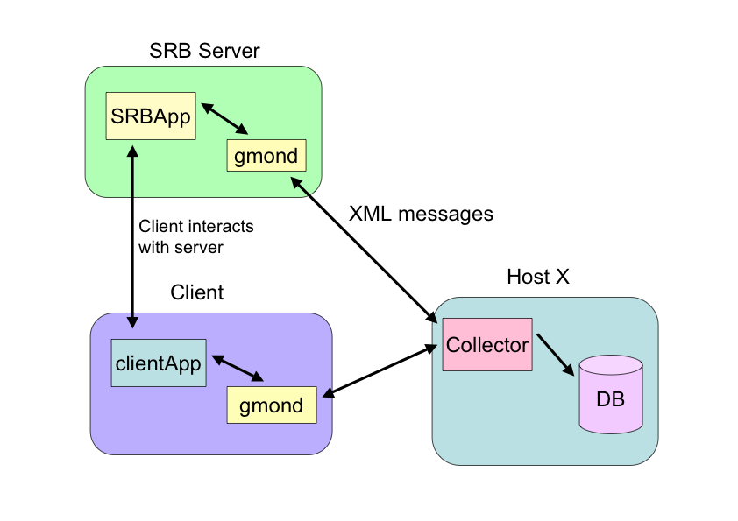
Figure 4: Schematic of the framework for performance measurements.

The Ganglia gmond daemons on the client and server machine are started by the Collector daemon before the performance tests start. The Collector collects the monitoring information in the form of XML messages at periodic intervals, extracts the information from the XML message and stores it in the SQLite database.
At this point the client application can be started and the performance measurements are recorded. The Collector reads from a configuration file the host names and applications that should be monitored as well as the interval at which the data should be collected. Figure 4 shows the cpu-load graph produced by the Displayer.In principle, the framework is not tied to the SRB and can be used for any application.

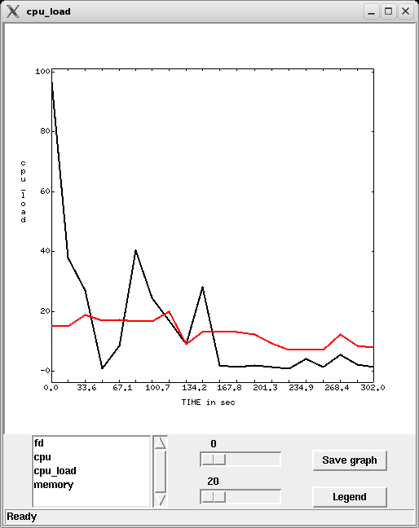

Figure 3: Graph of cpu-load produced by the Displayer application.

In order to measure the performance of an SRB system we have developed a set of tools based on the Scommands. The tools are capable of storing information in the SRB as collections, containers or simply files. The tools are configurable and can store large numbers of objects in flat or nested directory structures and are also capable of producing nested collections. The tools can also store variable amounts of metadata within the SRB.

Conclusion
Monitoring a production system is an essential aid in planning future extensions to the system, it can also be an essential aid in troubleshooting. Tools to carry out performance tests and collection, store and present the data are also important as they provide a means of providing a references against which the production system performance can be measured. Such tools can also help in troubleshooting problems either by comparing the performance against a benchmark, or simply by exercising a particular aspect of the system.
In this paper we have described a few of the tools that we have developed to help our production systems. All the tools we have developed are extensible as they have to accommodate new features or aspects of the production system.
References
- http://www.e-science.clrc.ac.uk/web/groups/Data-Management/Data-Management
- http://www.rcuk.ac.uk/escience
- http://www.sdsc.edu/srb
- http://www.nagios.org
- http://ganglia.sourceforge.net
- A. Weise, M.Sc Thesis (in preparation).
- C. Koebernick. M.Sc Thesis (in preparation).

* This work has been funded by a range of UK agencies incl. the e-Science Programmes of the Natural Environmental Research Council, the Engineering and Physical Science Research Council, the Council of the Central Laboratory of the Research Councils, the Biotechnology and Biological Sciences Research Council and the Joint Information Systems Committee.

